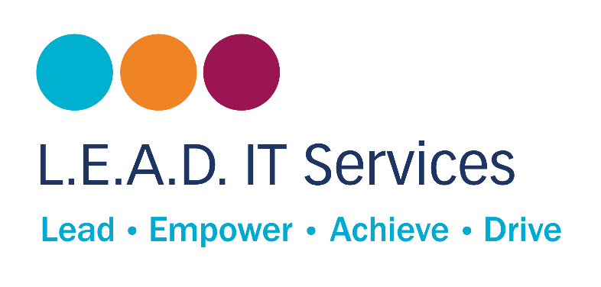
Environmental & Sustainability Policy 11/05/2026
Version | Date | Author | Status
1.0 | September 2021 | LEAD IT Services | Superseded
2.0 | May 2026 | LEAD IT Services | Current

This policy is supported by our Carbon Reduction Plan (CRP), updated annually. The CRP sets out specific emissions targets, actions, and timelines aligned with the commitments made in this policy.
1. Introduction
L.E.A.D. IT Services is a social enterprise providing fully managed IT services and support to schools, multi-academy trusts (MATs) and commercial organisations. We recognise that our operations - including on-site engineering, IT hardware provision and technology services - carry an environmental impact, and we accept our responsibility to manage and reduce that impact in a responsible, measurable and sustainable way.
Sustainability is more than a peripheral concern for us; it is integral to our identity as a social enterprise and to our mission of supporting communities, creating opportunities through apprenticeships and operating responsibly for future generations. This policy sets out our commitments, priorities and approach to environmental management across all areas of our business.
We are committed to achieving net zero carbon emissions by 2040, with clear, staged reductions along the way.
2. Scope and Application
This policy applies to:
- All L.E.A.D. IT Services employees, contractors and apprentices
- All office and operational activities
- Our supply chain and procurement decisions
- The IT services and advice we deliver to client schools, MATs and commercial customers
We will promote the principles of this policy with our clients and partners, supporting schools, MATs and commercial customers to reduce their own environmental footprint where we are able.
3. Our Net Zero Commitment
We are committed to achieving net zero carbon emissions by 2040. Our staged reduction targets are:
Short Term 1–2 Years | Establish a full carbon baseline (2026 baseline year). Reduce travel emissions by 25%. Transition office energy to a 100% renewable tariff. Formalise our device reuse and refurbishment programme.

Medium Term 3–5 Years | Reduce overall emissions by 25–30% against the 2026 baseline. Begin transition to an electric and hybrid vehicle fleet. Embed sustainability criteria into all procurement decisions. Ensure key suppliers have active sustainability policies.

Long Term By 2040 | Achieve net zero carbon emissions. Offset only those emissions that are genuinely unavoidable. Maintain and publish annual progress reports.
Detailed targets, actions and annual progress are set out in our Carbon Reduction Plan, which is reviewed and updated each year.
4. Engineer Travel
With 40–50 engineers regularly travelling to multiple client sites, travel is our largest and most controllable source of carbon emissions. We will take the following actions to reduce travel-related emissions:
- Optimise engineer scheduling to reduce unnecessary travel between sites
- Increase remote-first and remote-resolution support where technically appropriate
- Adopt regional clustering of school support to reduce cross-region journeys
- Transition the vehicle fleet to low-emission and electric vehicles over time
- Promote sustainable transport options for staff, including public transport where viable
5. IT Equipment & Lifecycle Management
The provision and disposal of IT hardware is a significant part of our environmental footprint. We will manage the full lifecycle of IT equipment responsibly:
- Further develop our device refurbishment and redeployment programme for client schools
- Extend the active lifecycle of devices across supported schools wherever possible
- Partner with certified recycling providers for end-of-life equipment disposal
- Prioritise energy-efficient hardware from suppliers with strong sustainability credentials
- Reduce unnecessary hardware refresh cycles and challenge procurement decisions that are not lifecycle-justified
- Advise our customers on energy-efficient IT infrastructure choices
6. Energy Efficiency
We will reduce energy consumption across our office and operational activities:
- Transition to a 100% renewable electricity tariff within 24 months
- Introduce LED lighting across our office facilities
- Implement and enforce device shutdown policies at end of working day
- Optimise the use of heating, ventilation and air conditioning (HVAC) systems
- Reduce paper use and promote electronic communications, storage, and document management
- Provide energy awareness training to all staff
7. Waste Reduction & Recycling
We will reduce waste generation and promote a circular approach to resources:
- Implement a waste management system that segregates waste streams and promotes recycling
- Reduce single-use plastics and packaging across office operations
- Prioritise reuse and repair of equipment over replacement
- Use certified recycling and disposal routes for IT hardware, peripherals and consumables
- Raise staff awareness of waste reduction through training and internal communications
8. Sustainable Procurement
We will integrate environmental criteria into how we select suppliers and purchase goods and services:
- Introduce sustainability criteria into all supplier selection and renewal decisions
- Engage key partners and suppliers on their own carbon reduction commitments
- Procure products that are energy efficient and have a demonstrably low environmental impact
- Reduce packaging waste and consolidate deliveries where possible
- Track procurement categories to support future carbon reporting and spend-based emissions estimation
- Promote the use of sustainable and responsibly sourced materials
9. Biodiversity & Ecosystem Protection
We recognise that environmental responsibility extends beyond carbon emissions. We will:
- Manage our land and facilities in a way that promotes biodiversity and ecosystem health
- Reduce the use of harmful chemicals and materials in our operations
- Avoid products and practices that are known to cause harm to the natural environment
- Engage in conservation and environmental activities in our local communities where opportunities arise
10. Culture, Training & Social Value
Embedding sustainability in our culture is as important as the operational actions we take. We will:
- Embed sustainability principles into all staff training programmes and induction
- Incorporate environmental responsibility into our apprenticeship curriculum
- Promote sustainable behaviours around travel, energy use, and waste in day-to-day working life
- Align our sustainability mission with our wider social value commitments: supporting communities, creating opportunities, and operating responsibly for future generations
As a social enterprise, we believe that the IT services we deliver should not only support education and business outcomes, but actively contribute to a more sustainable future for the communities we serve.
11. Carbon Measurement & Baseline
We will establish and maintain a robust emissions measurement framework:
- Adopt 2026 as our baseline measurement year
- Measure emissions across our primary sources: engineer travel, office electricity, IT hardware procurement and waste
- Use existing mileage tracking data as the foundation for travel emissions reporting
- Apply spend-based estimation for procurement and hardware categories where direct measurement is not yet available
Our Carbon Reduction Plan sets out the full measurement methodology and annual review process.
12. Monitoring, Governance & Continuous Improvement
We will ensure accountability and continuous improvement through:
- An annual carbon review drawing on mileage data, procurement spend and energy estimates
- Assigned internal responsibility for sustainability performance at Operations or Senior Leadership Team (SLT) level
- Regular environmental audits and self-assessments against this policy
- Measurable targets reviewed and updated each year in the Carbon Reduction Plan
- Stakeholder engagement, including seeking feedback from staff, clients and partners on our environmental performance
- Full compliance with all relevant environmental legislation and regulations
We will publish our Carbon Reduction Plan and relevant progress data in line with our commitments to transparency and accountability.
13. Conclusion
L.E.A.D. IT Services is committed to integrating environmental responsibility into every aspect of how we operate. We understand that as an IT services provider working closely with schools and public sector organisations, we have both the opportunity and the obligation to lead by example.
We will promote environmental awareness, encourage our staff and suppliers to adopt sustainable practices, comply with all relevant environmental legislation, and work collaboratively with our stakeholders to build a more sustainable future - for our communities, our clients, and generations to come.
This policy should be read alongside the L.E.A.D. IT Services Carbon Reduction Plan, which sets out our specific emissions targets, annual actions, and governance arrangements for achieving net zero by 2040.

Policy Owner  L.E.A.D. IT Services | Next Review Date  May 2027
Version  2.0 (supersedes v1.0, September 2021) | Related Documents  Carbon Reduction Plan (April 2026)

